Lecture 19, October 26, 2010 (Key Points)

Derivation of GIUH from Distributed Conservation equations in a network

A theoretical formulation allows us to abstract the basic properties of real systems and develop new intuitions and insights into their connections by a combination of computations for simple examples and attention to the wider range of data. As theory advances simple examples give way to the development and testing of more complex models that capture more of the essential characteristics of real systems. Careful tests of models provide a basis for new experiments and observations. In due course, continual interactions among theory, data and modeling lead to a new understanding of physical systems and improve the basis for scientific and engineering predictions. This key concept is illustrated here with four examples as part of modernizing the hydrology curriculum.

Recall the network-based hydrologic dynamical Eqs. (18.6) and (18.7) from Lecture 18,

(19.1)

where,

(19.2)

A solution of Eq. (18.6) requires four sets of physical elements and processes as mentioned in Lecture 18. Once all the physical processes in Eq. (18.6) are specified, it can be solved iteratively to obtain , which produces runoff hydrograph at the bottom of every link.
Solutions of Eq. (19.1) capture the spatial branching and geometric structure of a channel network through the terms 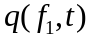 and 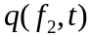, and produces runoff hydrograph at the bottom of every link. The first three examples are devoted to explaining how the width function GIUH arises as a solution of Eq. (19.1). For this purpose, assume that:

- The total area of both hillslopes draining into a channel link is the same for each link, i.e., [L²]. Assume that each link has the same length, .
- Runoff from the hillslope hydrograph is spatially uniform in the network, i.e. it does not vary from one link to another, 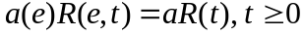.
- The flow velocity ν in the channel network is constant in time and uniform in space. Therefore, is a constant in Eq. (19.2).
- 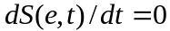 for all times,. This assumption means that the flow is in a steady state.

19.1 Width Function GIUH as a Solution of Distributed Mass Balance Equation

- We will simplify Eq. (19.1) following Gupta and Waymire (1998), and assume that time is discrete, say . This means that is the smallest time scale over which flows are observed. Discrete time is represented as, 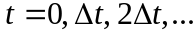. For notational simplicity, we write it as, 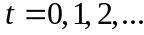

- Various terms on the right hand side of Eq. (19.1) are defined for a discrete time scale as follows. The flow out of the bottom of a link, 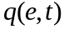, hillslope runoff, 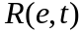, and discharges from upper links connected to link e, 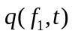 and 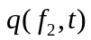, are defined for a time interval, 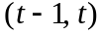 of unit length .

- Under assumption (iv), Eq. (19.1) modifies for discrete time scale as follows,

(19.3)

Note that it takes one unit of time for the runoff to reach the bottom of a link from the top of the link, which is represented in the first two terms on the right hand side.

- Assume that runoff from the hillslope hydrograph is applied instantaneously (over a time interval . It is the initial condition written as,

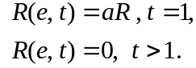 (19.4)

Note that the dimension of is [L/T].

5. Consider a simple network shown below to understand how Eqs. (19.3) and (19.4) are solved for computing the stream flow hydrograph at the outlet. Each link is given a number, e = 1,2,…7.

4 5 6 7

2 3

1(outlet)

6. We will solve Eqs. (19.3) and (19.4) starting with the bottom link and then recursively for all the links joining the bottom link. It takes unit time, for the runoff to traverse each link. Therefore, the runoff at the bottom of link 1 (outlet) is,

(19.5)

Note that the topologic width function for our network is, 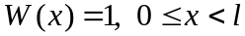. After transforming space to time, , it becomes, .

7. Let us consider the time interval,. According to Eq. (19.5), the runoff at time in links 2 and 3 is,

(19.6)

The runoff from links 2 and 3 arrives at the outlet of link 1 at time . It follows from Eq. (19.4) that,

(19.7)

8. It also follows from Eq. (19.4) that the runoff from links 4 and 5 arrives at the top of link 2, and from links 6 and 7 at the top of link 3, at time . It can be written as,

(19.8)

9. The runoff from all the four links 4, 5, 6 and 7 arrives at the top of link 1 at time, . The hydrograph at the outlet is given by applying Eq. (19.8) to (19.4) as,

(19.9)

10. Eqs. (19.5, (19.7) and (19.9) can be written in a compact form as,

(19.10)
11. The above example shows how the solution of a “spatially distributed mass balance equation” under idealized conditions determines the integrated response (GIUH) of a channel network to an instantaneously applied effective rainfall. It also shows that the width function is a key concept in understanding GIUH. That is our main reason for focusing on a width function GIUH rather than on other representations of GIUH that are not based on the width function concept (see Lecture 15).

19.2 Connection between Kirkby’s GIUH Representation and the Solution of the Mass Balance Equation

1. Recall from Lecture 16 (Eq. 16.4) that Kirkby defined a hillslope hydrograph, 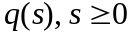 per unit length ([L²/T]) uniformly (in space) along all channel links. Assuming that the flow velocity ν is constant in time and space, the stream discharge at the outlet is given by the convolution equation,

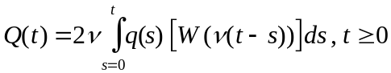 (19.11)

Our objective is show how the GIUH representation in eq. (19.11) is connected to a solution of “spatially distributed” mass balance Eqs. (19.1) and (19.2).

2. Our goal in item 1 is challenging because time is continuous in both Eqs. (15.4) and (19.11). We discretized time in Section 19.1 to simplify our demonstration because it is technically complex for continuous time.

3. We will assume as in Section 19.1 that time is discrete. The connection between Eq. (19.11) and solution of Eq. (19.1) can be understood in two steps:

- In the first step, we calculate runoff per unit time in the discrete time interval, in link 1 of the network in Section 19.1. Assume that hillslope runoff is constant in time, i.e., 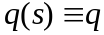. Also as explained in item 6 of Section 19.1, 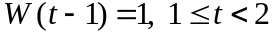. Substituting these assumptions in Eq. (19.11) gives,

, (19.12)

This expression is the same as in Eq. (19.4), because q represents hillslope runoff per unit length per hillslope. Total runoff per unit time over the link is 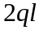. It is equal to , where is the runoff per unit area (units [L/T]), and “” is the area of both hillslopes.

- The second step is to use assumption (ii) given above Section 19.1. For discrete times, it is . Also, note that hillslope runoff at some time s reaches the outlet of link 1 at time t-s. Therefore, Eq. (19.10) generalizes as a “discrete convolution” and can be written as (Gupta and Waymire, 1998),

(19.13)
We adopt the convention, 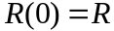. The GIUH expression in Eq. (19.10) is a special case of Eq. (19.13). It is connected to Kirkby’s GIUH via Eq. (19.11)

19.3 Spatial generalizations of GIUH

- Results in examples 1 and 2 extend spatially for the entire channel network simply by regarding the bottom of every link, e as the outlet of the sub basin above it. Each link has its own width function, as shown below in Fig. 19.1 for two links in a basin. We also showed several width functions at different spatial locations in GCEW using CUENCAS.

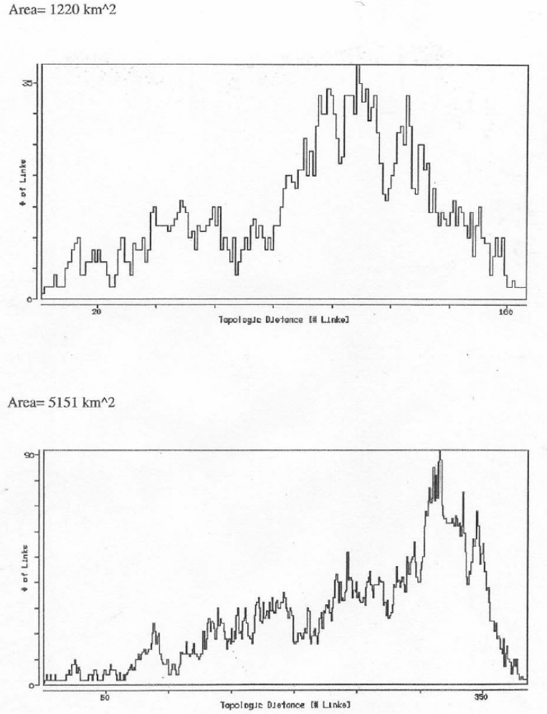

Figure 1 Two Local Geometric Width Functions for a Basin

2. Let, be the “local geomorphologic width function” of a network for each link . Eq. (19.13) generalizes to,

(19.14)

Notice that all these GIUHs are related with each other in space and time in a channel network. How can we begin to understand this complex relationship in river runoff? It requires scaling analysis of peak flows for RF-RO events. We will address this key issue in the next lecture.

References

Gupta, V.K. and E. Waymire, Spatial variability and scale invariance in hydrologic regionalization, In: Scale dependence and scale invariance in hydrology, (Ed. G. Sposito), Ch. 4, pp. 88-135, Cambridge University Press. 1998.

